**HAFIZUL ASYRUL BIN ZULKHAIRI**

**2015850328**

**13 June 2016**

Please answer all questions.

1. Write a program to calculate and display sum of two numbers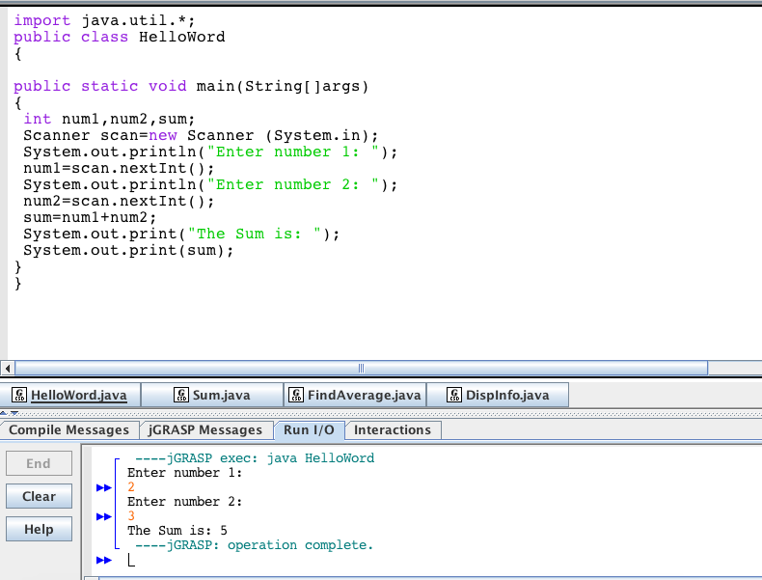
2. Write a program to find average of four numbers.

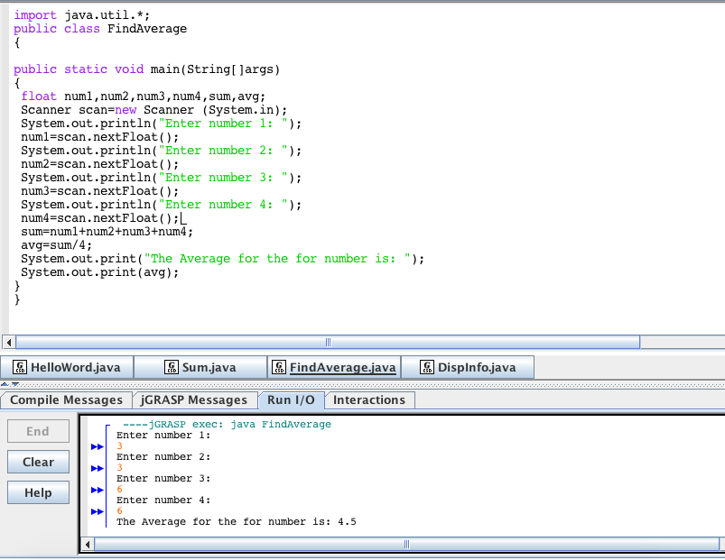

1. Write a program to accept Name, ic number, age and salary. Display these information.

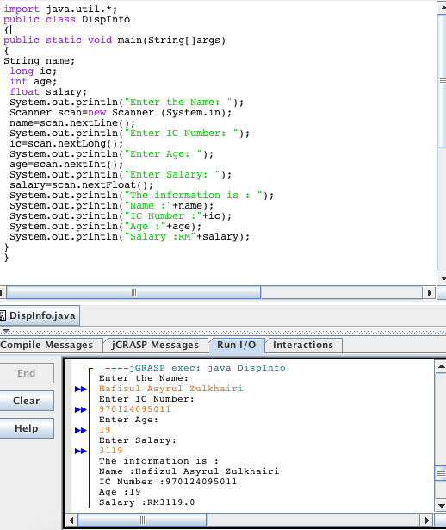

1. What is the use of scanner class?

The scanner class is a class in java which allow users to read value from various types.

1. List Java data types.

Byte,short,int,long,float,double,Boolean and char.

1. What is the difference between system.out.print and system.out.println

System.out.print will print on the same line meanwhile system.out.println will print on the new line.

Example:

